1. 8 – Puzzle Problem

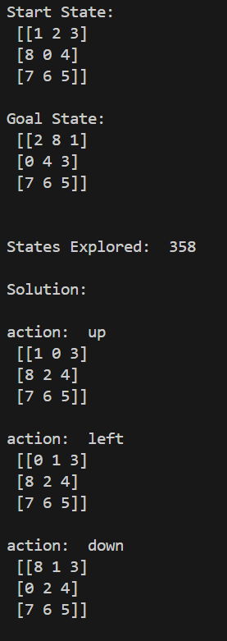

1. 8-Queen

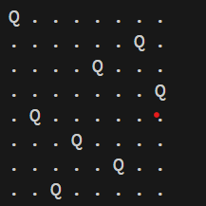

1. Water Jug Problem

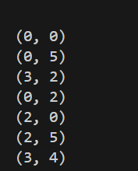

1. Cript-Arithmetic problem

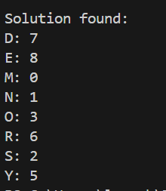

1. Missionaries Cannibal problem

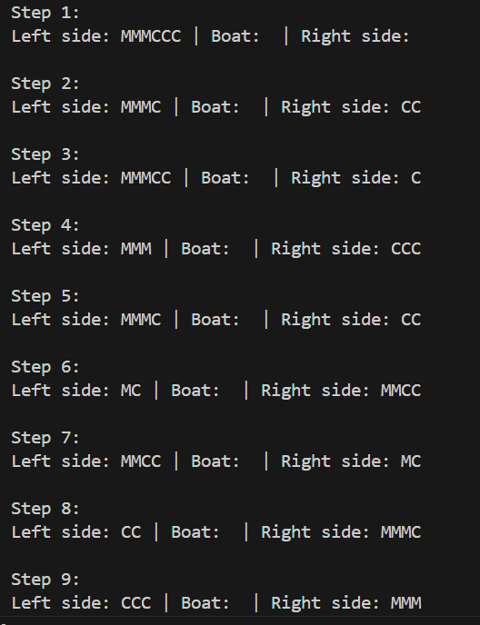

1. Vacuum Cleaner problem

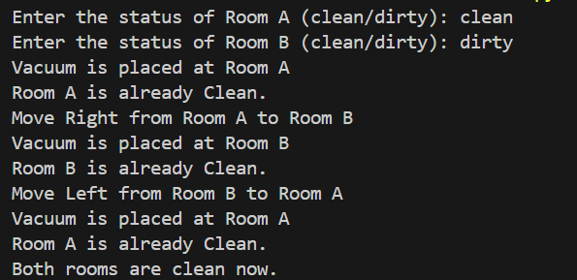

1. BFS

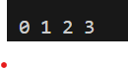

1. DFS

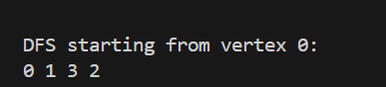

1. Travelling Salesman Problem

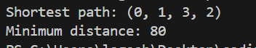

1. A\* algorithm

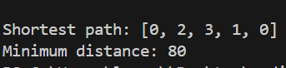

1. Map Coloring to implement CSP



1. Tic Tac Toe game



1. Minimax algorithm for gaming

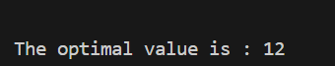

1. Apha & Beta pruning algorithm for gaming



1. Decision Tree



1. Feed forward neural Network

